
FEST Research Group

Final Year Project Weekly Report Log

(To be completed by Student)

S.No | Student Name: | Student ID:
 | Muhammad Umar | 36682
 | Muhammad Bilal Qamar | 35985
 | Adeel Arshsd | 36498

Project Title: Rakhwala (child security system)

Dr Mansoor Ebrahim
Supervisor:
Report Week: Date:

Planned Work
Achievements
To develop Database Schema Design (all-tables) related to each activity described in the UseCase . such as
- Child Parent registration,
- Family group creation
- Insert update delete operations.

Successfully design database .
SQL code:-
https://github.com/MuhammadBilalQamar/Rakhwala-Child-Security-System/blob/master/Back-End/Database/dump.sql
FEST Research Group

Proposed work
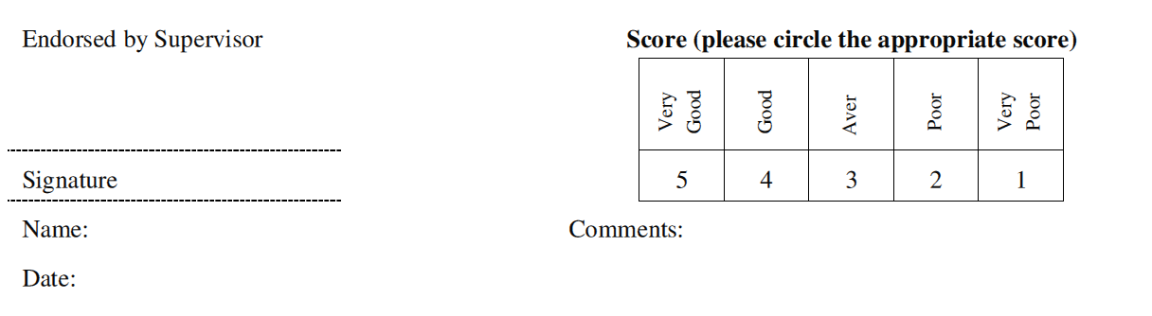
Proposal for develop REST apis.

